MPA Dynamics plug-in
Version 1, 28 February 2024 | 
Jeroen Steenbeek, Marta Coll
Ecopath International Initiative, Spain
DOI 10.6084/m9.figshare.25298758

- a brief users’ guide

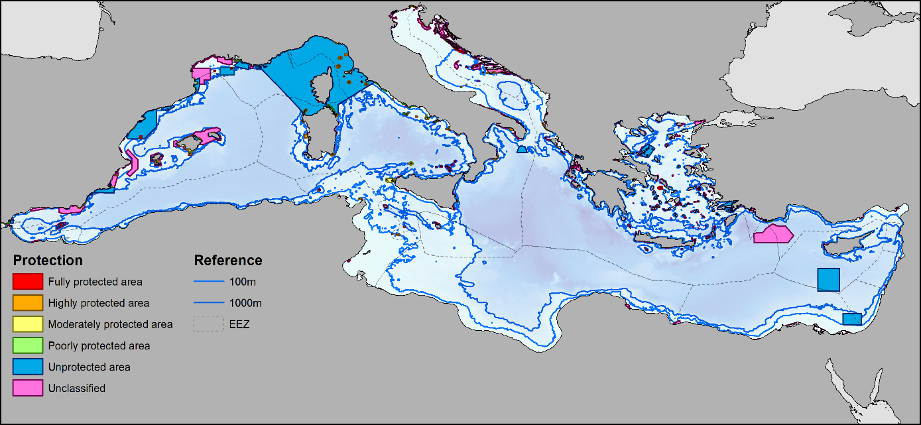

Ecopath with Ecosim software guides

Contents
Scope and purpose 1
Availability 1
Acknowledgements 1
Summary 2
Implementation 2
The MPA Dynamics main interface 3
The MPA Dynamics CSV file 4
CSV file layout 4
Editing the CSV file 4
Running the MPA Dynamics 5

Scope and purpose
This document provides usage instructions for the MPA Dynamics plug-in to the Ecopath with Ecosim food web modelling approach (Christensen and Walters, 2004; Heymans et al., 2016). If you have any questions, find bugs, or see ways to expand on this functionality please contact us at ewedevteam@gmail.com.
This document was last updated February 2024 to EwE version 6.7.0.18775 pre-release.

Availability
The MPA Dynamics plug-in is included with EwE version 6.6.6 and newer.

Acknowledgements
MPA dynamics was implemented by Jeroen Steenbeek and Marta Coll (Ecopath International Initiative, Spain) after an idea by Colette Wabnitz (University of British Columbia, Canada). Front image credits Gomei, M., Steenbeek, J., Coll, M., & Claudet, J. (2021). 30 by 30: Scenarios to recover biodiversity and rebuild fish stocks in the Mediterranean (p. 29). Rome: WWF Mediterranean Marine Initiative.

Summary
Ecospace, the spatial-temporal module of the Ecopath with Ecosim (EwE) approach, offers the ability to define fisheries restricted areas. In the software, these areas are referred to as MPAs, and are used to block out fishing from specific Ecospace cells for a given fleet and given month(s). MPA maps can overlap in space, thus allowing the user to apply different enforcement rules in a single cell. This provides a powerful mechanism to restrict fisheries across space.
A shortcoming of the EwE approach was a limited inability to alter fishing enforcement over time once a simulation is in progress: once configured, the MPA enforcement was kept static for the duration of an Ecospace run. This meant that Ecospace could not be used to assess the impacts of changing MPA enforcement at any point in time past the Ecospace simulation start year.
To overcome this limitation, the MPA Dynamics plug-in was built.

Implementation
In Ecospace, each MPA has three configurable sets of parameters: i) a monthly pattern that states whether the MPA is open or closed, ii) a table that defines which fleets that are banned from fishing in each MPA; and iii) the map cells to which restrictions applies. MPAs can spatially overlap (Figure 1). In the traditional
Whereas the spatial temporal data framework (Steenbeek et al., 2013) can be used to change the spatial layout of each MPA, the MPA Dynamics plug-in now also provides a mechanism to change the enforcement of each MPA over time, such as which months the MPA is open or closed to fishing, and which fleets are allowed or banned from fishing within an MPA.
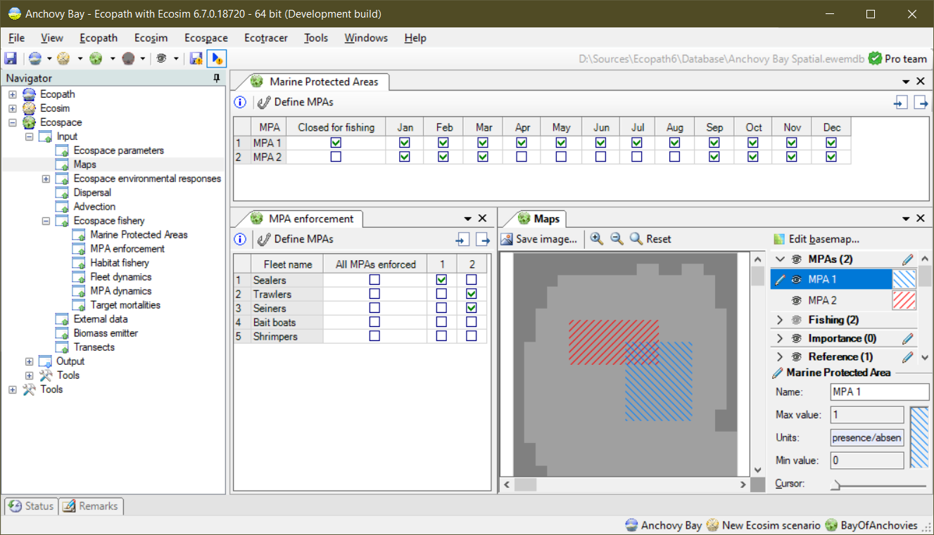
iii
ii
i
Figure 1 - MPA parameterization in the Ecospace interface: i) the monthly pattern of MPA closures; ii) MPA enforcement; and iii) the maps that indicate where the different MPAs are located. As shown here, MPAs can overlap.
The MPA Dynamics plug-in nests itself in the EwE navigation tree among the Ecospace inputs, and is configured via a simple CSV file of a pre-defined format, as described below.

The MPA Dynamics main interface
The plug-in can be accessed from “EwE > Navigator > Ecospace > Input > Ecospace fishery > MPA Dynamics”, and brings up the interface as shown in Figure 2.
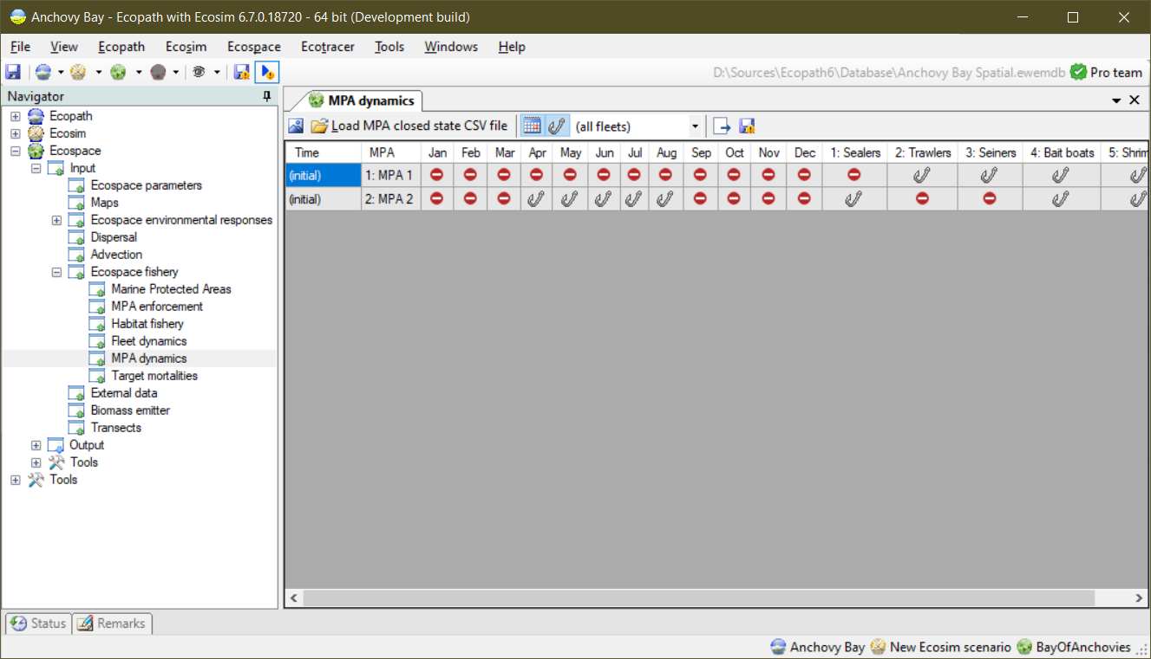
Figure 2 - MPA Dynamics interface with a control toolbar and a data grid. Here, the data grid reflects the MPA enforcement configuration from Figure 1. At the initial Ecospace time step, “MPA 1” is closed all year and only affects fleet “1: Sealers”. “MPA 2” is only open April-August and only affects fleets “2: Trawlers” and “3: Seiners”.
The plug-in has the following components:
A toolbar to control the functioning of the plug-in, with the following options from left to right:
“Export to CSV file”. This option will write out the MPA configuration state in Ecospace to a CSV file, which functions as a foundation for creating the MPA Dynamics CSV file (see section “Modifying the MPA enforcement CSV file”), below.
“Load MPA closed state CSV file”. This option will load the CSV file with changes to MPA enforcement into the MPA Dynamics plug-in;
Two filter buttons “Show months” and “Show fleets”, along with a fleet selection combo box. These options serve to limit the columns to show in the MPA Dynamics data grid (see below);
“Run with Ecospace”. This option enables or disables whether the MPA Dynamics plug-in runs with Ecospace.
“Autosave closure statistics”. This option toggles whether the plug-in should write out a CSV file that states when and how MPA enforcements were changed. This file is meant for you, the user, to check and troubleshoot if the MPA Dynamics plug-in is applying changes as intended.
A data grid that shows the start-up MPA enforcement configuration in Ecospace, and if MPA Dynamics CSV file has been loaded, an row for each time steps that the enforcement of a single MPA needs to change.

The MPA Dynamics CSV file
The MPA Dynamics plug-in is controlled through a simple CSV file that contains a row for each time step that the enforcement of a single MPA needs to change.

CSV file layout
The CSV file requires the following columns:
- A column that can be called either “Timestep” or “Date”;
- A column that is called “MPA”. MPA column values are either one-based numbers that correspond to the sequential number of the MPA, or can contain the name of the MPA. It is generally a good practice to put name values within double quotes (e.g., “MPA name”);
- Twelve columns that denote the months of the year. The column names can be “m1” to “m12”, the three-letter abbreviation of the month names in the Windows display language, or the full month name;
- Columns for each fleet in your model. The column names can be “f1” to “fX” (where X is the sequential number of the last fleet in your models) or the fleet names WITHOUT the fleet number. Values in these columns determine whether a fleet can or cannot fish within the MPA for this row.
Conventions:
- Column names, mpa names, month names, month abbreviations and fleet names are not case sensitive;
- “Timestep” column values are positive numbers that start at 1, where 1 is the first Ecospace time step. “Date” columns can be formatted in a range of ways ("yyyy/MM", "yyyy-MM", "MM/yyyy", "MM-yyyy", "yyyy/M", "yyyy-M", "M/yyyy", "M-yyyy") and are translated to time steps relative to the Ecospace start year.
- To CLOSE (or enforce) an MPA in a given month, or the PROHIBIT a fleet from fishing in a given MPA, enter one of the following characters in the appropriate cell: "1yv+t"
- To OPEN an MPA in a given month, or the ALLOW a fleet to fish in a given MPA, enter one of the following characters in the appropriate cell: "0nx-f"
- For any month or fleet column that you do not want to make a change the enforcement, just leave the cell empty.
- The MPA Dynamics can write out a basic CSV file that reflects your MPA and fleet setup. Just add rows to this file to implement your own MPA dynamics.
Limitations:
- The MPA Dynamics can ONLY work with commas to separated columns. Semi-columns and other column separators are not supported at this time. Sorry.

Editing the CSV file
To have EwE write out the MSP Dynamics CSV file:
- Load an Ecospace model and make sure to have at least one MPA(s) defined
- Launch the MPA Dynamics plug-in from “EwE > Navigator > Ecospace > Input > Ecospace fishery > MPA Dynamics”
- Observe that the initial MPA enforcement state is correctly reflected in the data grid.
- Export the initial MPA enforcement state to a CSV file by clicking “Export to CSV file”.
- You will be asked to browse to a folder where to store the file, and how to name it. Do so, and close the pop-up.
- The EwE status panel will now show you where the file was saved.
Now, open the file that you just saved in Excel or an equivalent, and add rows. The following rules apply:
- Each row must provide values for the first two columns:
- Column 1 “Timestep” = the one-based timestep when the change is to take place
- Column 2, “MPA” = the number of the MPA affected by the change
- Columns 3-15, named “mX” where X is a number from 1-12, indicate the months that the MPA is enforced.
- Columns 16 and onward are for the fleets defined in your model, with each fleet its own column.
- For every row that you add past time step 1, values for columns 1 and 2 MUST be provided. Cells for all the other columns can be
  - left empty (e.g., nothing changes)
  - set to “1” or “y” to turn ON enforcement for a given column
  - set to “0” or “n” to turn OFF the enforcement in a given column.

Consider, for instance, the following example CSV file:
Table 1 – An Excel snapshot of a sample CSV file that change enforcement of MPA 1
Timestep | mpa | m1 | m2 | m3 | m4 | m5 | m6 | m7 | m8 | m9 | m10 | m11 | m12 | fleet1 | fleet2 | fleet3 | fleet4 | fleet5
1 | 1 | 1 | 1 | 1 | 1 | 1 | 1 | 1 | 1 | 1 | 1 | 1 | 1 | 1 | 0 | 0 | 0 | 0
1 | 2 | 1 | 1 | 1 | 0 | 0 | 0 | 0 | 0 | 1 | 1 | 1 | 1 | 0 | 1 | 1 | 0 | 0
25 | 1 |  |  | 0 |  |  |  |  |  | 0 |  |  |  |  |  |  | 1

In the CSV file (Table 1) shows the Ecospace start-up situation for MPAs 1 and 2, and adds one line with changes in the enforcement of MPA 1. At time step 25 (January of simulation year 3), MPA 1 will no longer be in force for months 3 and 9, effectively opening the MPA for fishing for March to September. However, the MPA will from time step 25 onward also be applicable to fleet 4, which can now no longer fish in MPA 1 alongside fleets 2 and 3.

Table 2, below, will have the same effect when loaded in the MPA Dynamics, but some users may prefer not to leave any columns empty:

Table 2 - The same data as shown in Table 1, but with all cells filled
Timestep | mpa | m1 | m2 | m3 | m4 | m5 | m6 | m7 | m8 | m9 | m10 | m11 | m12 | fleet1 | fleet2 | fleet3 | fleet4 | fleet5
1 | 1 | 1 | 1 | 1 | 1 | 1 | 1 | 1 | 1 | 1 | 1 | 1 | 1 | 1 | 0 | 0 | 0 | 0
1 | 2 | 1 | 1 | 1 | 0 | 0 | 0 | 0 | 0 | 1 | 1 | 1 | 1 | 0 | 1 | 1 | 0 | 0
25 | 1 | 1 | 1 | 0 | 0 | 0 | 0 | 0 | 0 | 0 | 1 | 1 | 1 | 0 | 1 | 1 | 1 | 0

Once you are happy with the temporal changes that you wish to apply to Ecospace, do the following:
- Save the CSV file and, if you are using Excel, close Excel to free the file for further use,

Running the MPA Dynamics
To make the MPA Dynamics work, do the following:
- In the MPA Dynamics tool, click “Load MPA closed state CSV file”
- Browse to the file that you just edited, and load it
- The MPA Dynamics grid should now show you the new rows that you added

To run the new data through the MPA Dynamics plug-in, do the following:
- Ensure that the MPA Dynamics plug-in is active by pressing the “Run with Ecospace” option. It will stay depressed to indicate it is active.
- Now start an Ecospace run as you normally do. The plug-in will integrate in the Ecospace flow.
- Whenever the MPA Dynamics makes a change to enforcement, it will notify the user in the EwE status panel.

